**UPPCL PASSWORD RESET PROCESS**

1. Get UPPCL VPN Access.
2. Edit Host file present at location “C:\Windows\System32\drivers\etc”.
3. Enter the hostname given below in the host file.

“**10.128.51.10 openam1 openam1.tnd.uppclonline.com”**

**“10.128.50.240 openam1.prod.uppclonline.com openam1”**

1. Get the authorization token from the POST API “<http://openam1.tnd.uppclonline.com:8080/openam/json/authenticate>”

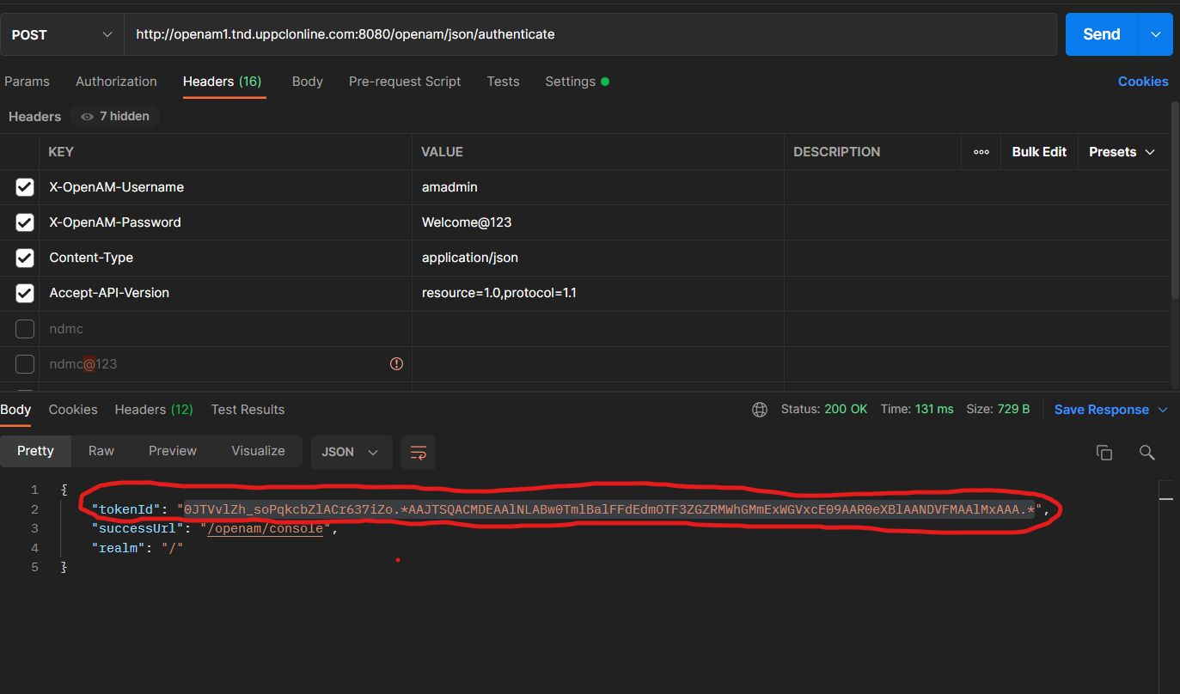

Note: Make sure to select these 4 headers while generating the token.

1. Copy the token Id marked in the above picture.
2. Search the user from the GET API by entering the username for which you want to change the password. “[http://openam1.tnd.uppclonline.com:8080/openam/json/users/**user_name**](http://openam1.tnd.uppclonline.com:8080/openam/json/users/user_name)”
3. Make sure to paste the token ID you have copied in the **“iPlanetDirectoryPro”** Header as shown in the Picture below.

1. Once you found the user change the password of the user using the PUT API by entering the username in the API

“ [http://openam1.tnd.uppclonline.com:8080/openam/json/users/**user_name**](http://openam1.tnd.uppclonline.com:8080/openam/json/users/user_name)”

1. Make sure to paste the token ID you have copied in the **“iPlanetDirectoryPro”** Header as shown in the Picture below.

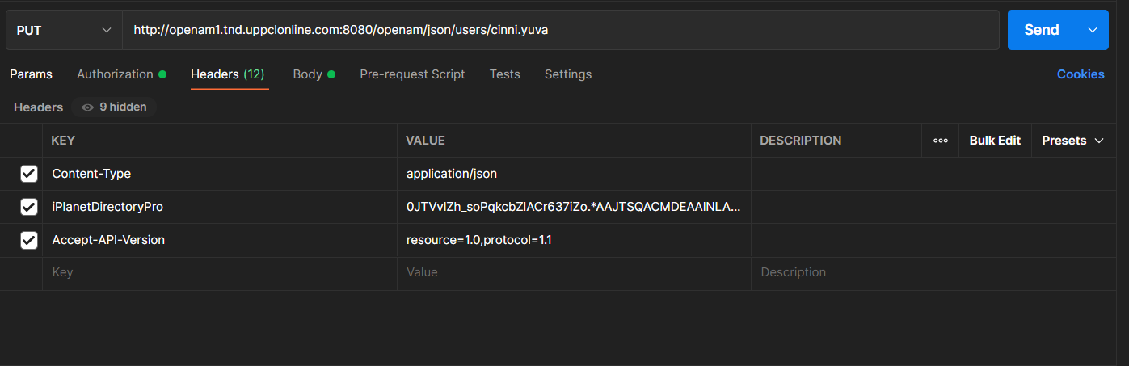

1. Enter the desired password in the body of the API before sending the request. 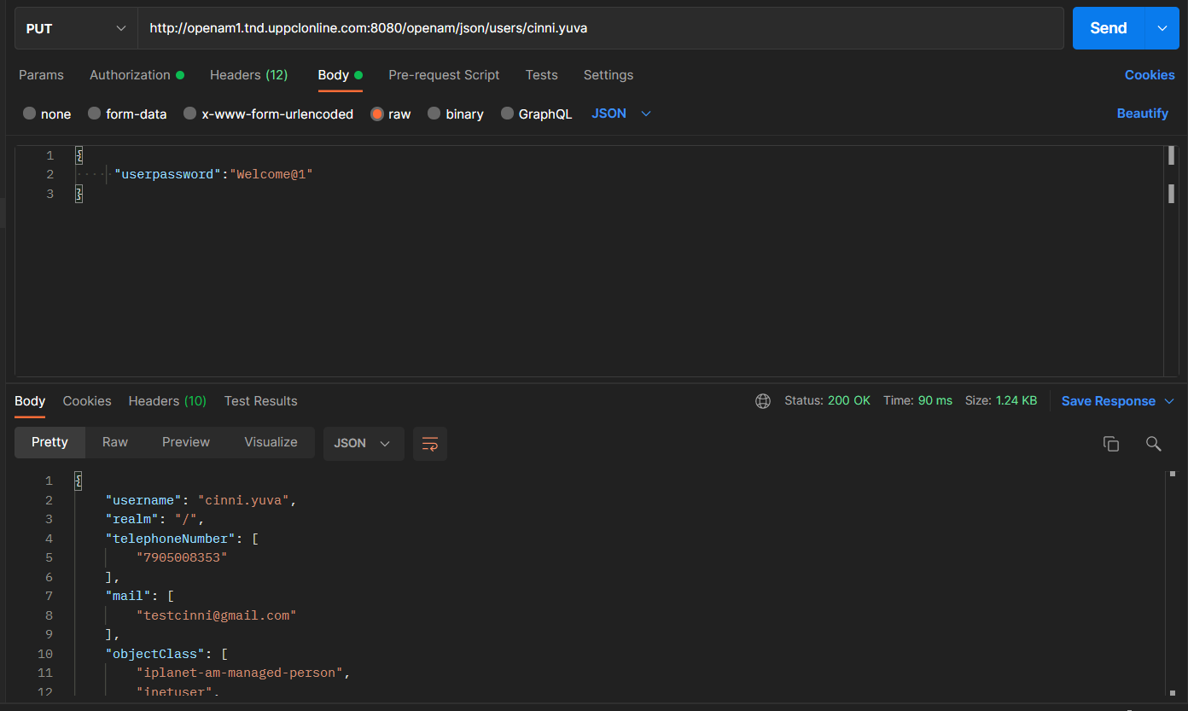
2. For the Production enviornment chage the API’s to:

Token: “[**http://openam1.prod.uppclonline.com:8080/openam/json/authenticate**](http://openam1.prod.uppclonline.com:8080/openam/json/authenticate)**”**

Search: “**http://openam1.prod.uppclonline.com:8080/openam/json/users/user_name**”

Reset: “[**http://openam1.prod.uppclonline.com:8080/openam/json/users/user_name**](http://openam1.prod.uppclonline.com:8080/openam/json/users/user_name)**”**

1. Access the POSTMAN File given Below For the above Task.

